Tree of Life
- Eubacteria ("True bacteria", mitochondria, and chloroplasts) - Prokaryote
- Archaea (Methanogens, Halophiles, Sulfolobus, and relatives) - Prokaryote
- Eukaryotes (Protists, Plants, Fungi, Animals, Algae, etc.)

Domains Archaea and Bacteria
Until the 1980's with the advent of genomic sequencing techniques, bacteria were the only recognized group of single-celled organisms to have procaryotic cells not containing a nucleus. Phylogenetics (see references 1-4 below) enabled the discovery of another group of procaryotes that was initially and informally named "archaebacteria" (now renamed Archaea since their genomes are far distant from bacteria). Actually, many archaea had long been studied extensively, but with the idea that the archaea were bacteria; sequence analysis revealed that this group of procaryotes needed placement within the Universal tree of life as a distinct Domain, alongside Bacteria and Eukarya.
Procaryotic cells are very tiny, 1 micron across, compared to 10 to 100 microns in most eucaryotic cells. Prokaryotes are found everywhere eukaryotes are found, as well as in many environments too extreme for eukaryotes. Instances of procaryote and eukaryotes symbiosis abound. Despite their diminutive size, procaryotes are the most abundant and ubiquitous form of life on Earth. They comprise some 90 % of the total biomass in the seas. The organelles of eukaryotes (mitochondria in animals and chloroplasts in plants) are thought to be evolutionary descendents of Bacteria that invaded, or were captured by, primitive eukaryotesmore than a billion years ago. Numerous types of extant eukaryotic cells are inhabitated by endosymbiotic procaryotes. Procaryotes exhibit an amazing diversity of types of metabolism to power themselves that is nonexistent in eukaryotes. For example, the metabolic processes of nitrogen fixation (conversion of atmospheric nitrogen gas to ammonia) and methanogenesis (production of methane) are unique to procaryotes and enormously impact the nitrogen and carbon cycles in nature. Most of the earth's atmospheric oxygen was produced by free-living bacterial cells.
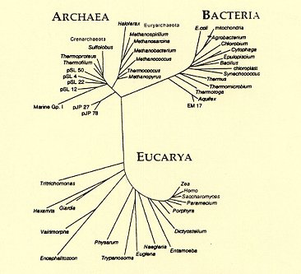
The figure above depicts at once many groups within the universal tree of life with the euclidian distance in the figure representing an evolutionary distance as determined by small subunit ribosomal RNA (ssrRNA) analysis.

